**Once your practice is done please go to aws console ->EC2->Instance->Actions->Instance State -> Stop**

**Create EC2 Machine in AWS**:

Login to AWS and click on Services and select EC2:

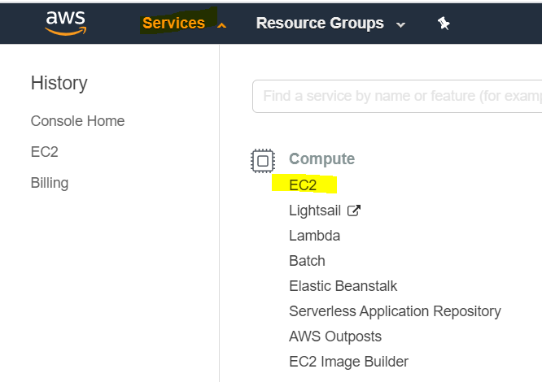

Click in Instances:

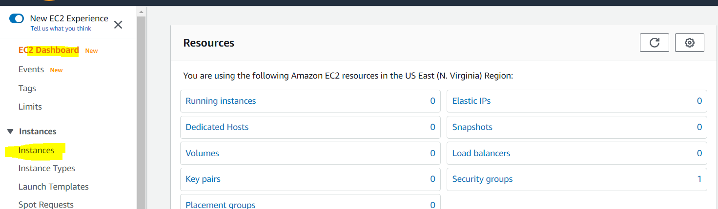

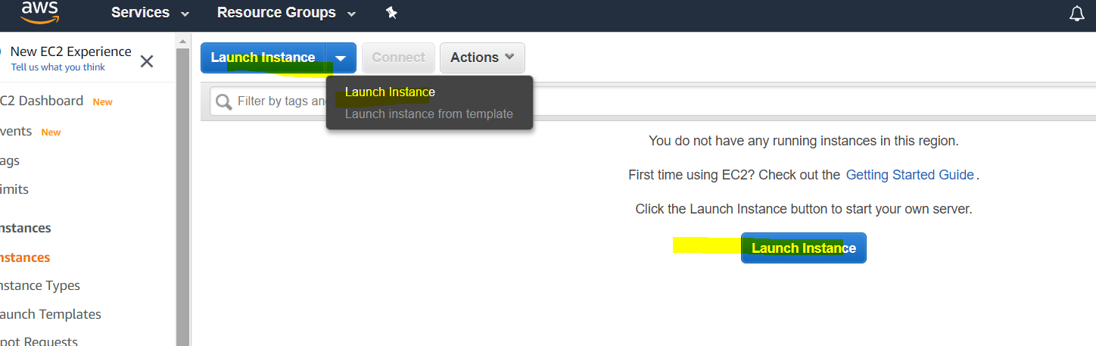

Select free tier and select RHEL.

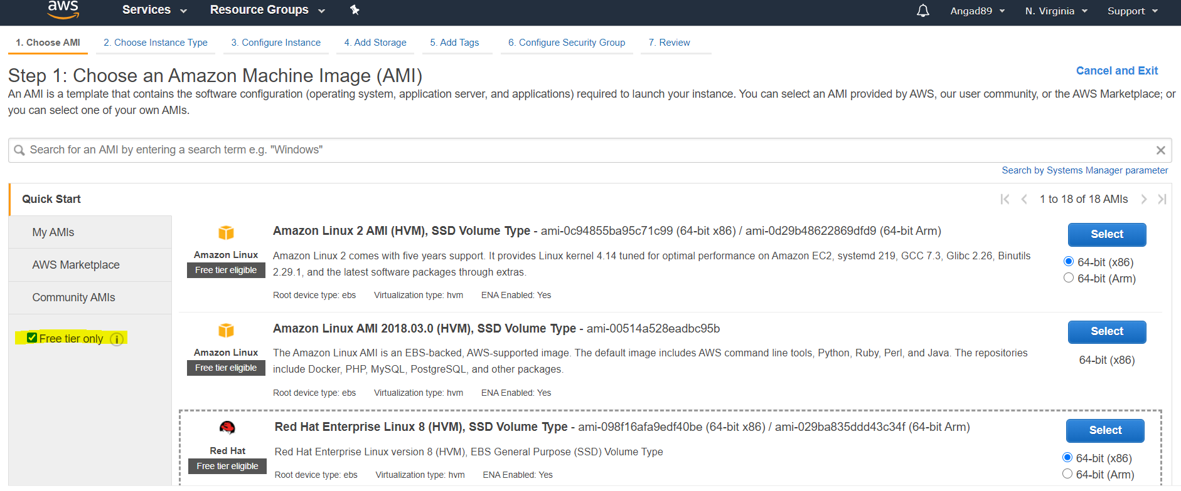

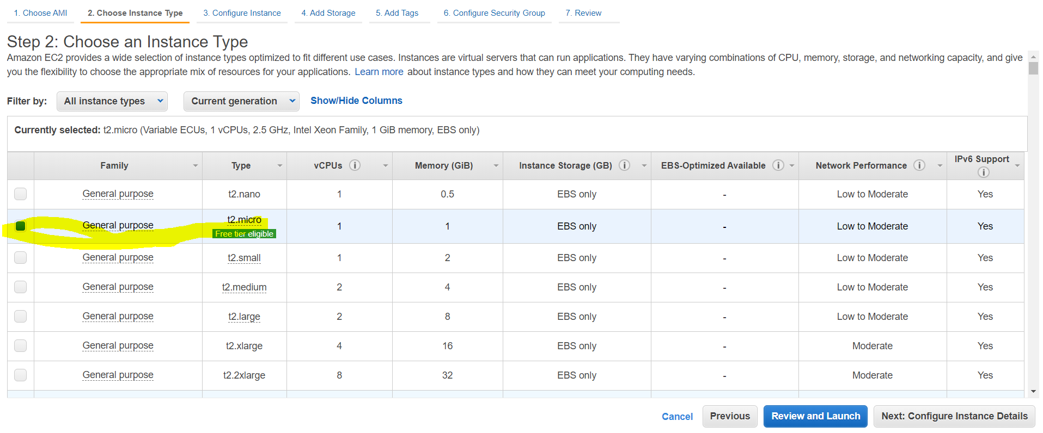

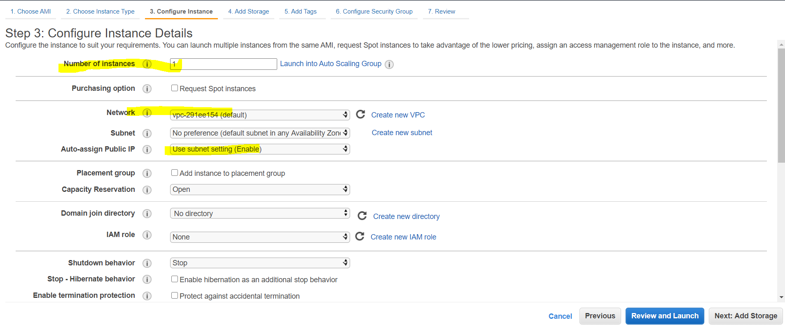

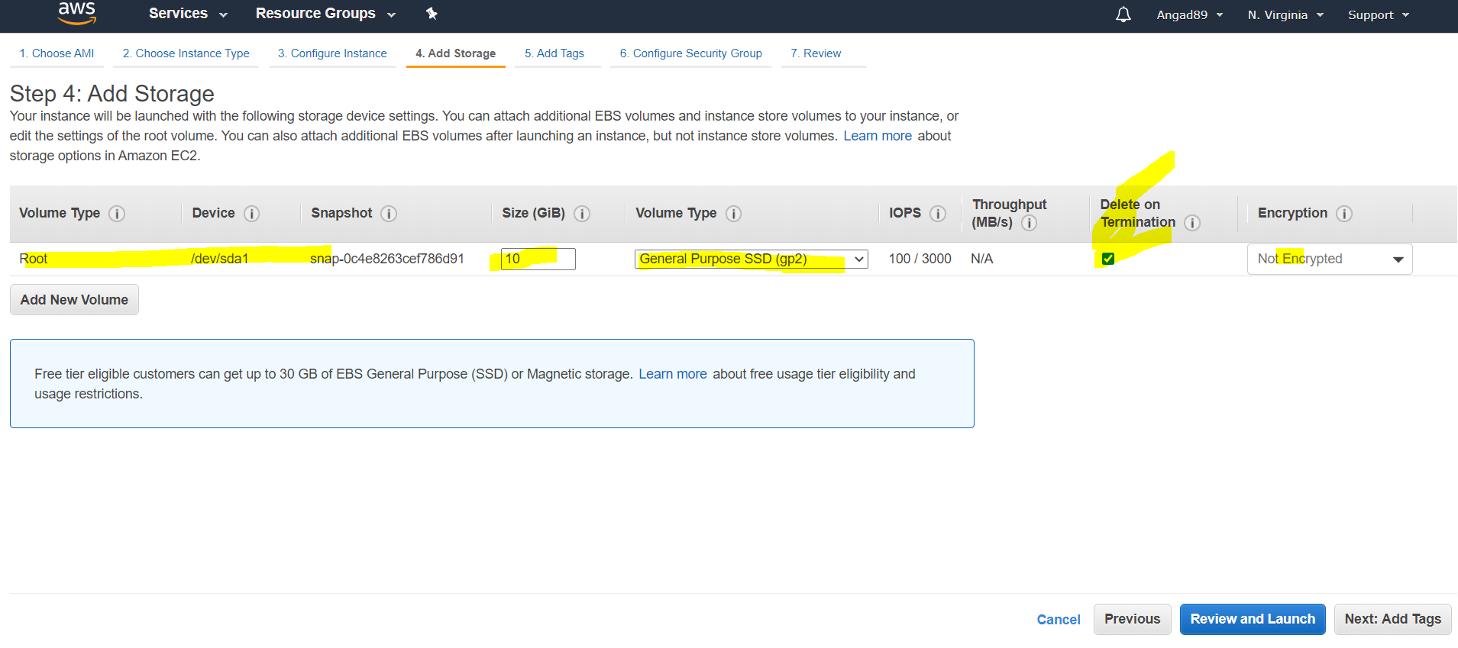

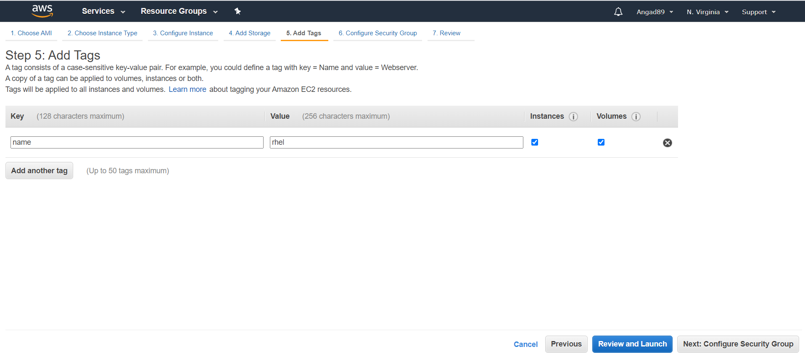

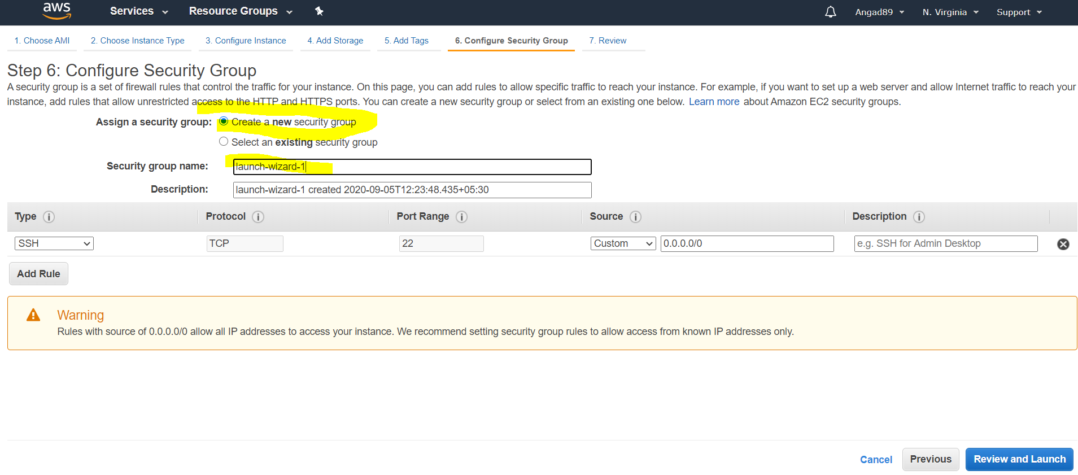

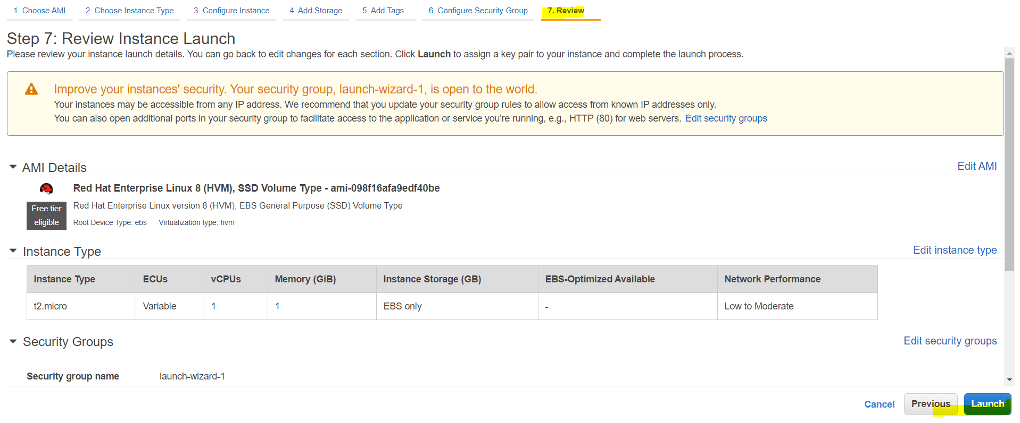

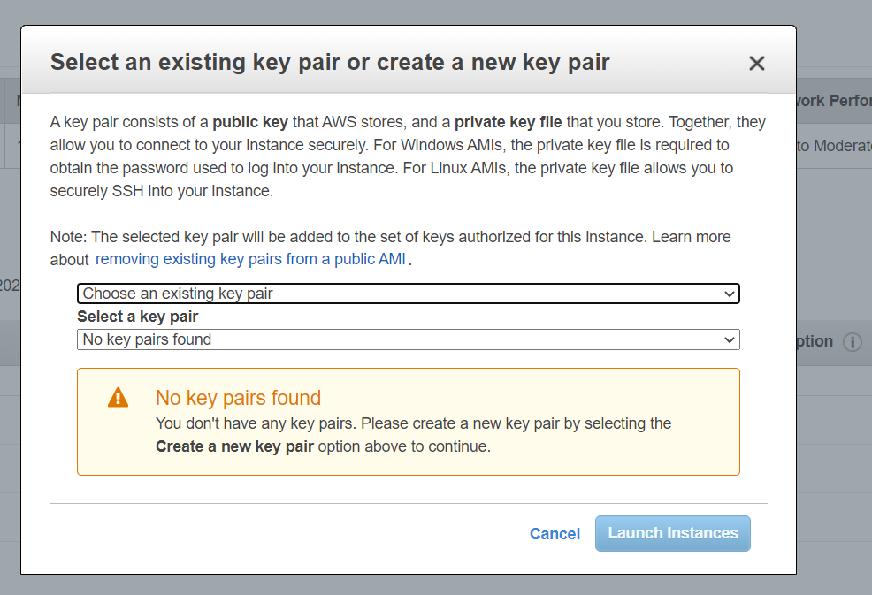

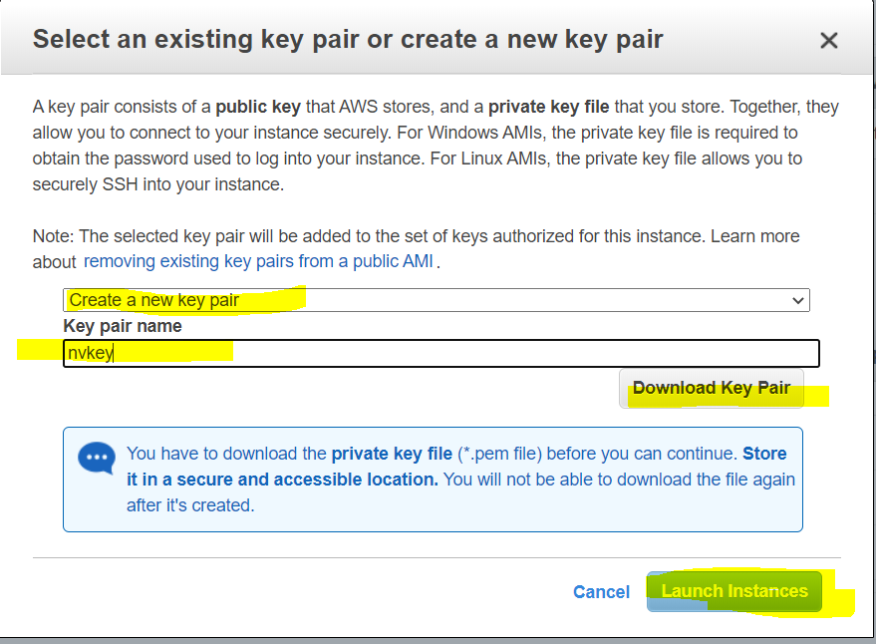

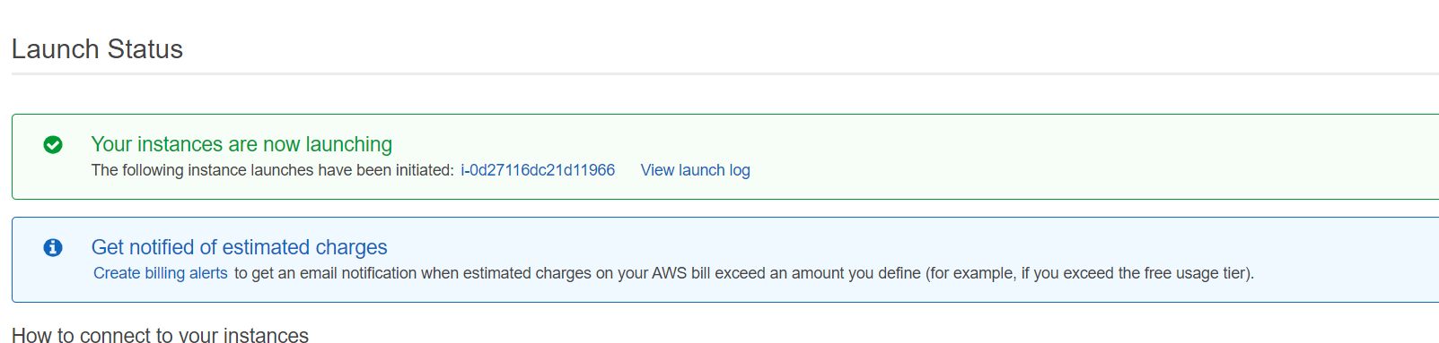

For Login to machine.

Download the putty microsoft installer and install putty.

<https://www.chiark.greenend.org.uk/~sgtatham/putty/latest.html>

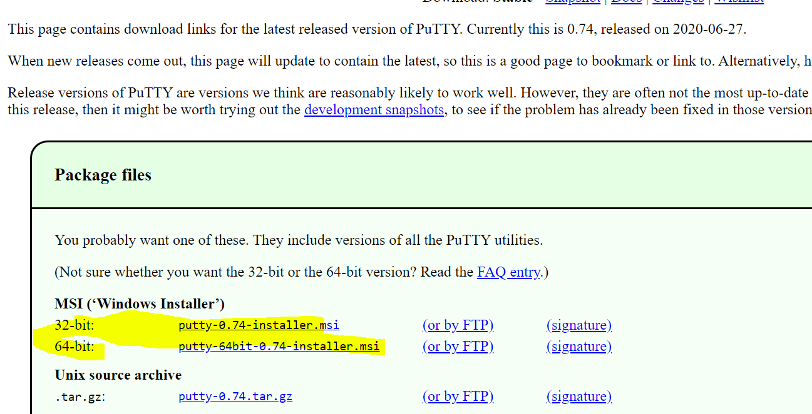

Open puttyGen and load the “downloaded public key” from aws to puttygen to generate the private key.

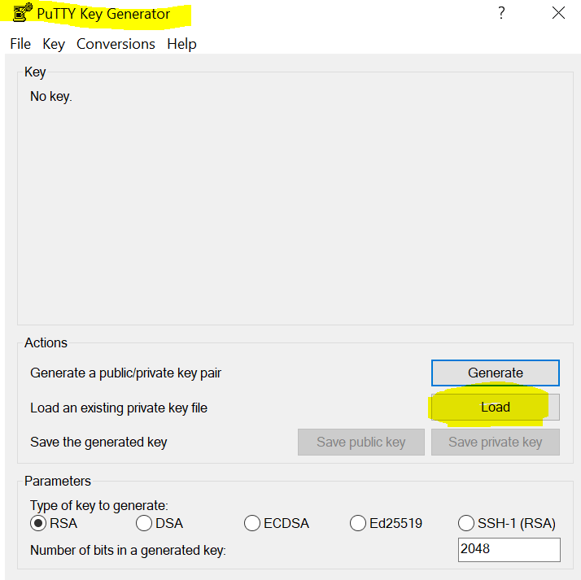

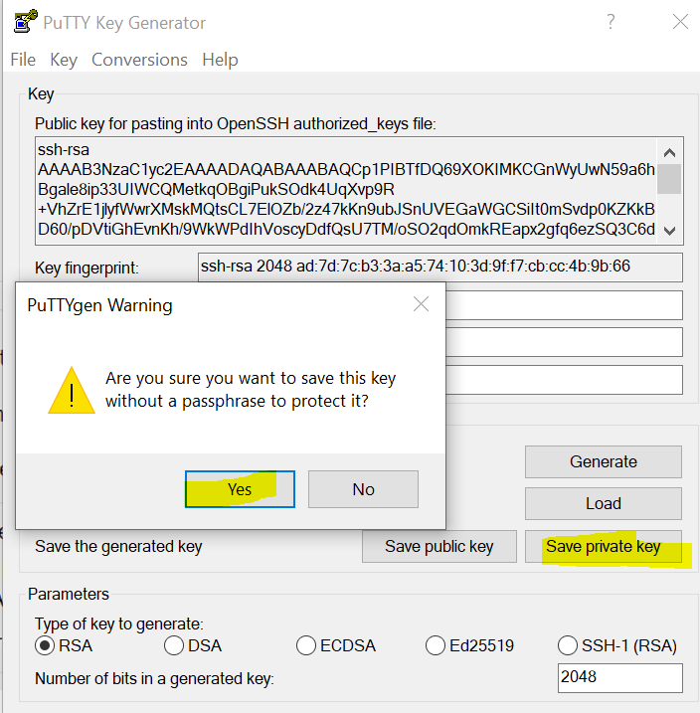

Open Putty and provide the public IP and click on expand “SSH”.

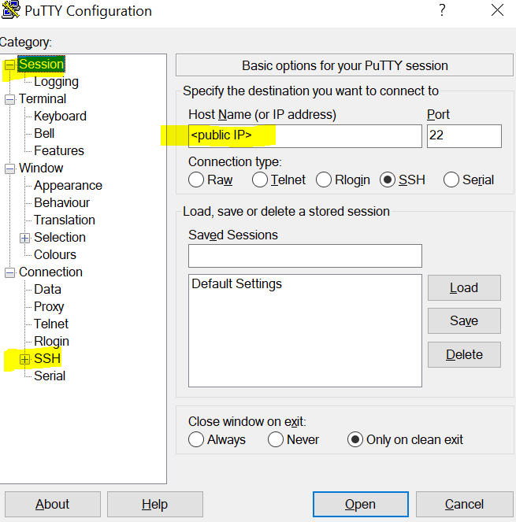

Browse the public key which was downloaded.

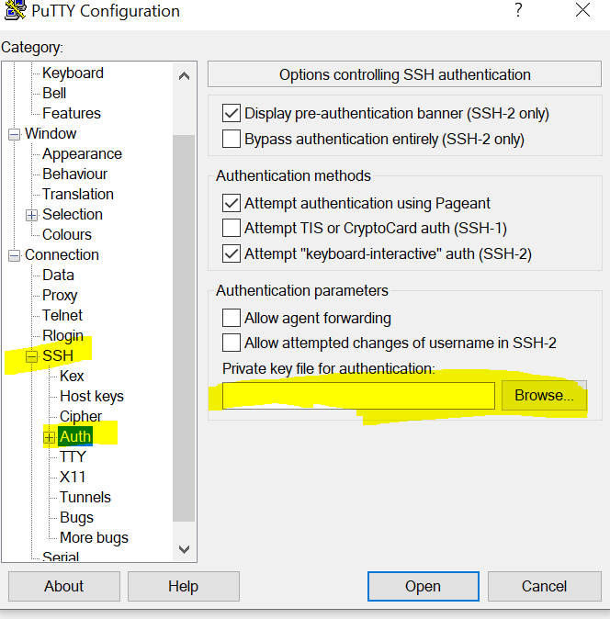

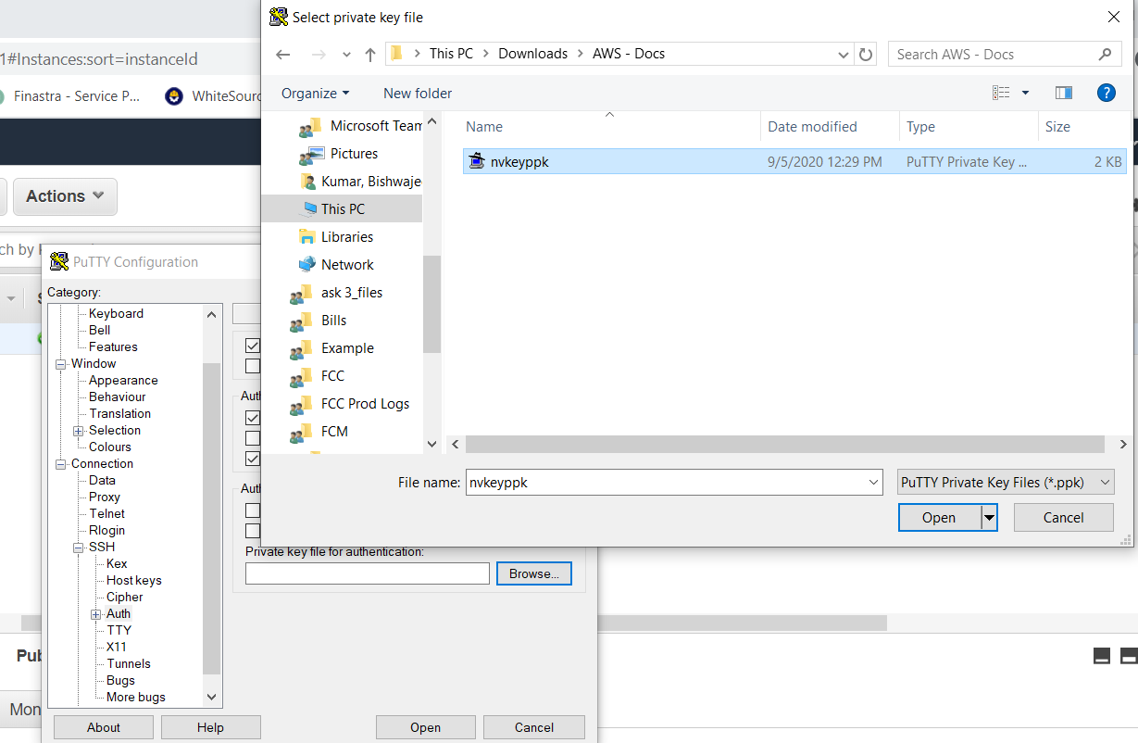

**Important**:

Please stop the AWS VM.

**Once your practice is done please go to aws console ->EC2->Instance->Actions->Instance State -> Stop**